**All components of this case study have to be executed in R.**

DATA PREPARATION:

1. Make a grouped bar chart depicting the hour-wise trip request made at city and airport respectively. You can aggregate the data for all 5 days on the same axis of 24 hours. Each bar should correspond to an hour and pick-up point (city / airport) should be displayed in two colors.

*Please paste a copy of your plot here.*

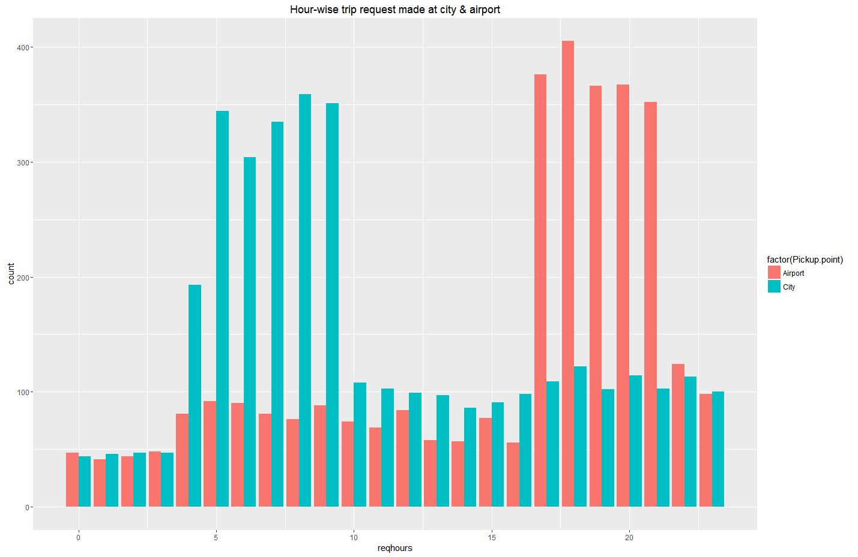

1. In the bar chart (question 1), you’ll be able to see 5 major time blocks based on the frequency of requests made at the city and airport. You have to now divide the request-time into 5 time-slots described below. Make an additional column “Time_Slot” which takes these 5 categorical values depending on the request time:
   * Pre_Morning
   * Morning_Rush
   * Day_Time
   * Evening_Rush
   * Late_Night

Note: The division of time-slots may not have one right answer.

*Plot a bar chart for number of trips made during different time-slots in R and paste the image here*

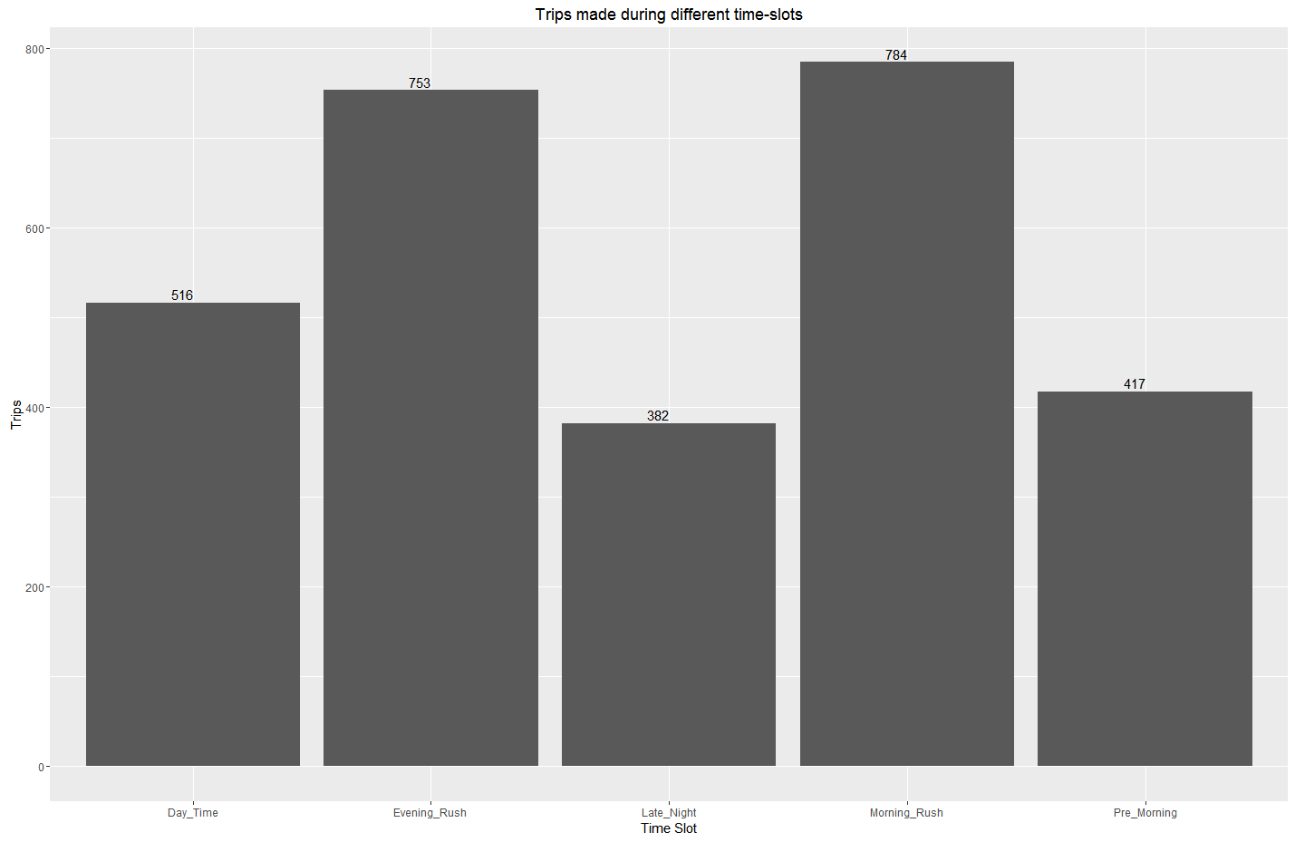

*<image>*

Also give the count of the number of trips made during different time slots you have decided.

|  |  |  |
| --- | --- | --- |
| Time Slot | Total Requests | Total Trips |
| Pre_Morning | 1074 | 417 |
| Morning_Rush | 1866 | 784 |
| Day_Time | 821 | 516 |
| Evening_Rush | 2115 | 753 |
| Late_Night | 890 | 382 |

PROBLEM IDENTIFICATION:

1. Make a stacked bar chart where each bar represents a time slot and y axis shows the frequency of requests. Different proportions of bars should represent the completed, cancelled and no cars available out of the total customer requests.

*Please paste a copy of your plot here.*

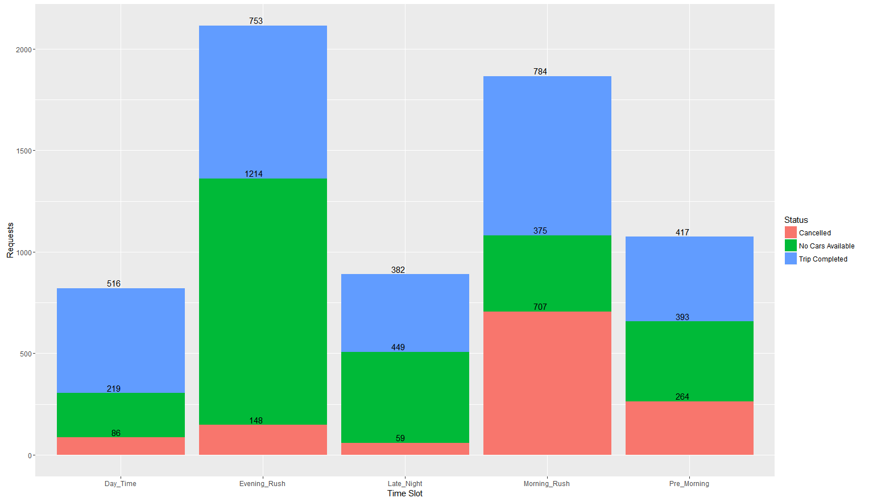

*<image>*

1. Visually identify the 2 most pressing problems for Uber, out of the 15 possible scenarios (5 slots * 3 trip status).
2. Enter your diagnosis results here:

* Problem 1: Morning Rush High Cancellations  in city
* Problem 2: Evening Rush No Cars at airport

Problem 1:

1. For the time slot when problem 1 exists, plot a stacked bar chart to find out if the problem is more severe for pick-up requests made at the airport or the city. As a next step, you have to determine the number of times this issue exists in that time slot.  
     
   Find the percentage breakup for the total number of issues in this time slot based on the pick-up point.

*Please paste your plot here.*

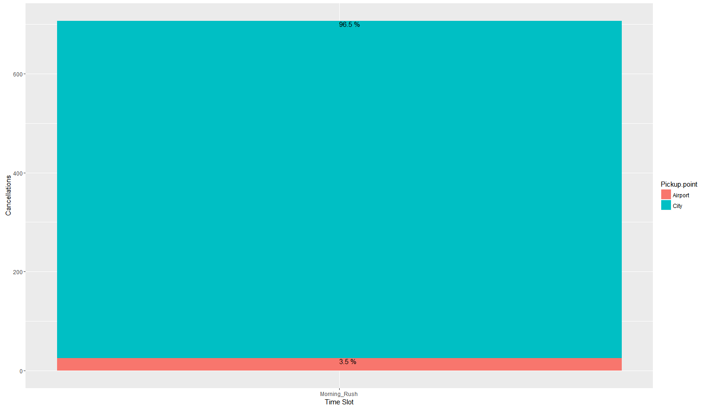

*<image>*

* What is the percentage of total issues at (based on pick-up point):
* Airport : 96.5%
* City : 3.5%

1. Now let’s find out the gap between supply and demand. For this case, the demand is the number of trip requests made at the city, whereas the supply is the number of trips completed from city to the airport.

*No. of trip requests made in city: 1457*

*No. of trips completed from city to airport: 434*

1. What do you think is the reason for this issue for the supply demand gap? (Write the answer in less than 100 words).  
   From the graphs its clear that there is   
     
   a.) Spike in demand from city to airport in Morning Rush. For spike [Refer plot 3] , table & above graph there is spike demand at city in Morning Rush slot   
   c.) There is less demand at airport in Morning Rush slot , See [Refer plot 3] , table & above graph there is less demand at airport in Morning Rush slot   
   d.) Drivers in city are canceling requests to airport apparently because they know of less demand at airport.
2. What is your recommendation to Uber (Not more than 50 words)?

*a.) Additional Compensate/Award drivers by increasing their revenue share at this slot and route to make it attractive than other routes.*

Problem 2:

1. For the time slot when problem 2 exists, plot the stacked bar chart to find out if the issue is for pick-up request made at the airport or the city. Just like problem 1:

* Find the percentage breakup for issue based on the pick-up point for the time slot in which problem 2 exists.

Please paste your plot here.

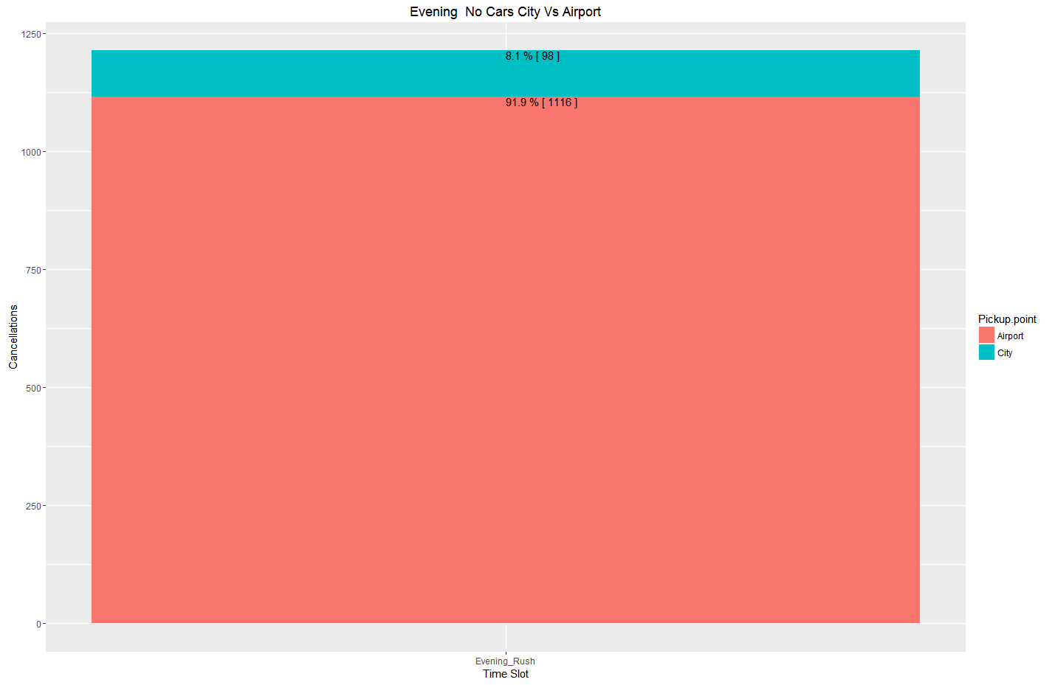

*<image>*

* What is the percentage of total issues at (based on pick-up point):
* Airport : 91.9%
* City : 8.1%

1. Now let’s find out the gap between supply and demand. For this case, the demand is the number of trip requests made at the airport, whereas the supply is the number of trips completed from airport to the city.

*No. of trip requests made at the airport:1570*

*No. of trips completed from airport to the city:361*

1. What do you think is the reason for this issue for this supply demand gap. (Not more than 100 words)?   
   a) Surge in demand at airport in this hour [Refer plot 3] and table. Probably More flights land in evening rush slot.   
   b) Not enough cabs available at airport to meet demand.
2. What is your recommendation to Uber (Not more than 50 words)?

*a.) additional Compensate/Award drivers by increasing their revenue share at this slot and route to make it attractive than other routes.*